Curriculum Vitae
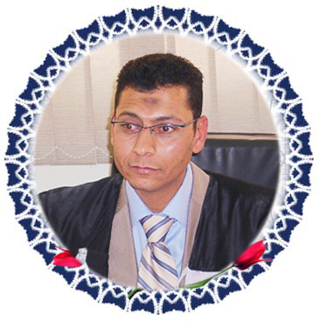
Personal Data :-

Sur name :- Sallam
First name :- Osama
Full name :- Osama Ibrahim Sallam
Date of Birth :- July 27th 1967
Place of Birth :- Tanta, Gharbia Governorate.
Nationality :- Egyptian
Sex :- Male
Martial Status :- Married
Address :- 444 Gamal Abd El- Naser El- Mandara Bahry- Alex.
Tel. :- Mobil. 0124424944
E-Mail :- dr_sallam_osama@yahoo.com

Present Occupation :- Lecture in Faculty of Arts- Assuit University- 31-6-2007
Sciences : Egyptology
Off. No. :- 0882311186
Fax No. :- 0882328515
E-Mail www.aun.edu.eg/fac_arts/e_art/index.htm

Educational background :-
2007
PH. D.
Study of The Strategic Unites Defensives on The Egyptian Border at The Pharonic New Kingdom Period .
With Estimate: The First Honour, in The Institute of Zagazig university

2001
M. A.
The Libyan’s In Egypt at The Pharonic New Kingdom Period(1575- 1085 B. C).
With Estimate: Excellent, in The Institute of Zagazig university

2002
Excavation study in Prehistory Archaeological field school held at Nabta Playa by
American Mission in Aswan.

1990
Faculty of Arts, Egyptology from Tanta University.

Professional Experience :-
2007
Lecture of Faculty of Arts in Assiut University
2006
Director of West Matrouh antiquities
2005
Chief inspector of West Matrouh antiquities
1997
Inspector of Matrouh antiquities
1996
Inspector of Middle Delta antiquities
1994
Inspector of Minufia antiquities
1992
Inspector of Marina antiquities

I have been excavated in Marina , Sersena, Siwa, Aswan, Maria (Alex.),
Matrouh, Abar El-Kanayis ( in the Middle road between Matrouh to Siwa), Zawiet Umm El-Rakhem, Abo Markiek, Romail lake and Celopatra site.

Activites :-
I have been delegated to represent the Supreme Council of
Antiquities as Inspector for many expeditions :-
* Liverpool Mission (UK) at Zawyet Umm El- Rakhame (1997- 2004 ).
** Pennsylvania Mission ( USA) in Alex., Conducting underwater
exploration between Ras El-Hikma to Ras Abu Lahw 2000 .
*** American Mission, Training Prehistory at Nabta Playa in Aswan 2002
**** DAI- Cairo Mission (Germany) at Siwa Oasis, excavating and restoring
at the Oracular Complex ( Aghurmi, Umm Ubayda) 2003
**** Martin Luther Mission Wittenberg at Abar El- Kanayis in Matrouh
excavating and survey 2006

List of Published Scientific works :-
El- Ahram El-Arabie Magazine 5-9-2009 pp. 28&29

* Articl in Ahram Ebdo 2002, pp. 34& 35.

** Articl in El AKhbar newspaper 25/ 6 / 2002, p. 6

*** Articl in " Ancient Egypt " Magazine vol. 2, issue. 2, 8& 9 / 2001.

**** Articl in El AKhbar newspaper 17 / 7 / 2001 P. 4

***** Articl in El AKhbar newspaper 22 / 3 / 2001 , P. 4.

All Subjects which I studied it in Faculty of Arts :

Language Skill :-
Arabic - mother tongue
English – good spoken and written

Computer Skills :-
Experienced in using Microsoft office Applications.
Such as word , Excel , power point and Sbss.
Experienced in using Internet , E-Mails and Chat.

Name : Osama Ibrahim Sallam
Signed :-
Osama sallam
Date :-
2 / 7 / 2009

